Section 4.1: Scatter Diagrams and Correlation

Objectives: Students will be able to:
Draw and interpret scatter diagrams
Understand the properties of the linear correlation coefficient
Compute and interpret the linear correlation coefficient

Vocabulary:
Response Variable – variable whose value can be explained by the value of the explanatory or predictor variable
Predictor Variable – independent variable; explains the response variable variability
Lurking Variable – variable that may affect the response variable, but is excluded from the analysis
Positively Associated – if predictor variable goes up, then the response variable goes up (or vice versa)
Negatively Associated – if predictor variable goes up, then the response variable goes down (or vice versa)

Key Concepts:

Scatter Diagram
Shows relationship between two quantitative variables measured on the same individual.
Each individual in the data set is represented by a point in the scatter diagram.
Explanatory variable plotted on horizontal axis and the response variable plotted on vertical axis.
Do not connect the points when drawing a scatter diagram.

Properties of the Linear Correlation Coefficient
  - The linear correlation coefficient is always between -1 and 1
  - If r = 1, then there is perfect positive linear relation between the two variables
  - If r = -1, then there is perfect negative linear relation between the two variables
  - The closer r is to 1, then the stronger the evidence for a positive linear relation
  - The closer r is to -1, then the stronger the evidence for a negative linear relation
  - If r is close to zero, then there is little evidence of a linear relation between the two variables. R close to zero does not mean that there is no relation between the two variables
  - The linear correlation coefficient is a unitless measure of association

Observational Data:
If bivariate data are observational, then we cannot conclude that any relation between the explanatory and response variable are due to cause and effect

Example 1:
 | 1 | 2 | 3 | 4 | 5 | 6 | 7 | 8 | 9 | 10 | 11 | 12
x | 3 | 2 | 2 | 4 | 5 | 15 | 22 | 13 | 6 | 5 | 4 | 1
y | 0 | 1 | 2 | 1 | 2 | 9 | 16 | 5 | 3 | 3 | 1 | 0

Draw a scatter plot of the above data

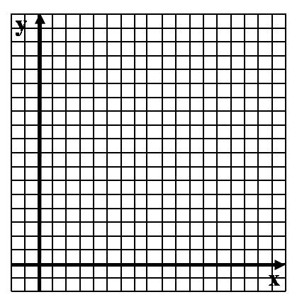

Compute the correlation coefficient

Homework: pg 203 – 211; 4, 5, 11-16, 27, 38, 42

Section 4.2: Least-Squares Regression

Objectives: Students will be able to:
Find the least-squares regression line and us the line to make predictions
Interpret the slope and the y-intercept of the least-squares regression line
Compute the sum of squared residuals

Vocabulary:
Residual – aka, the error; difference between observed value of y and the predicted value of y
Method of Least-squares – minimizes the sum of the residuals squared
Least-squares regression line – line that minimizes the sum of the squared errors

Key Concepts:

Example :1
x | 0 | 1 | 2 | 3 | 4 | 5 | 6 | 7 | 8 | 9
y | 89.2 | 86.4 | 83.5 | 81.1 | 78.2 | 73.9 | 64.3 | 71.8 | 65.6 | 66.2
Find the least-squares regression line

What does the model predict for x = 5? What is the residual from the above?

Is this model appropriate for x = 15? Why or why not?

Homework: pg 221 – 225; 2, 3, 6, 9, 19, 21
Section 4.3: Diagnostics on the Least-Squares Regression Line

Objectives: Students will be able to:
Compute and interpret the coefficient of determination
Perform residual analysis on a regression model
Identify influential observations

Vocabulary:
Coefficient of determination, R² – measures the percentage of total variation in the response variable that is explained by the least-squares regression line.
Deviations – differences between predicted value and actual value
Total Deviation – deviation between observed value, y, and mean of y, y-bar
Explained Deviation – deviation between predicted value, y-hat, and mean of y, y-bar
Unexplained Deviation – deviation between observed value, y, and predicted value, y-hat
Influential Observation – observation that significantly affects the value of the slope

Key Concepts:

Is the Linear Model Appropriate?
Patterned Residuals
If a plot of the residuals against the explanatory variable shows a discernible pattern, such as a curve, then the response and explanatory variable may not be linearly related

Variance of the Residuals Constant
If a plot of the residuals against the explanatory variable shows the spread of the residuals increasing or decreasing as the explanatory variable increases, then a strict requirement of the linear model is violated. This requirement is called constant error variance.

Influential Observations
Influential observations typically exist when the point is an outlier relative to its X-value

Outliers and Influential Observations
Remove only if there is justification to do so

Homework: pg 235 – 239; 2, 5, 9, 11-15, 29
Section 4.4: Nonlinear Regression: Transformations

Objectives: Students will be able to:
Change exponential expressions to logarithmic expressions and logarithmic expressions to exponential expressions
Simplify expressions containing logarithms
Use logarithmic transformations to linearize exponential relations
Use logarithmic transformations to linearize power relations

Vocabulary:
Coefficient of determination, R² – measures the percentage of total variation in the response variable that is explained by the least-squares regression line.
Deviations – differences between predicted value and actual value
Total Deviation – deviation between observed value, y, and mean of y, y-bar
Explained Deviation – deviation between predicted value, y-hat, and mean of y, y-bar
Unexplained Deviation – deviation between observed value, y, and predicted value, y-hat
Influential Observation – observation that significantly affects the value of the slope

Key Concepts:
Some relationships that are nonlinear can be modeled with exponential or power models
  - y = a b^{x} (with b > 1)
  - y = a b^{x} (with b < 1)
  - y = a x^{b}

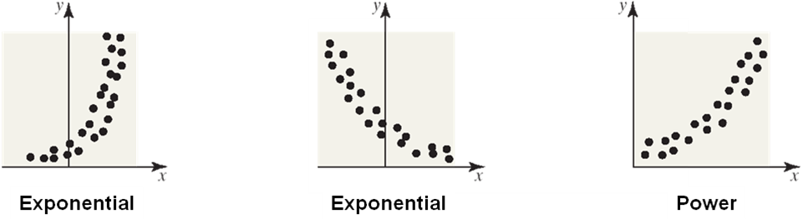

Exponential Model analyzed with Least Squares (Linear Regression)
- We started with an exponential model
y = a b^{x}
- We transformed that into a linear model
Y = A + B X
- After we solve the linear model, we match up
  - b = 10^{B}
  - a = 10^{A}
- In this way, we are able to use the method of least-squares to find an exponential model

Power Model analyzed with Least Squares (Linear Regression)
- We started with a power model
y = a b^{x}
- We transformed that into a linear model
Y = A + B X
- After we solve the linear model, we find that
  - b = B
  - a = 10^{A}
- In this way, we are able to use the method of least-squares to find a power model

Homework: TBD
Chapter 4: Review

Objectives: Students will be able to:
Summarize the chapter
Define the vocabulary used
Complete all objectives
Successfully answer any of the review exercises
Use the technology to compute required objectives

Vocabulary: None new

Problem 1: The scatter diagram to the right shows a
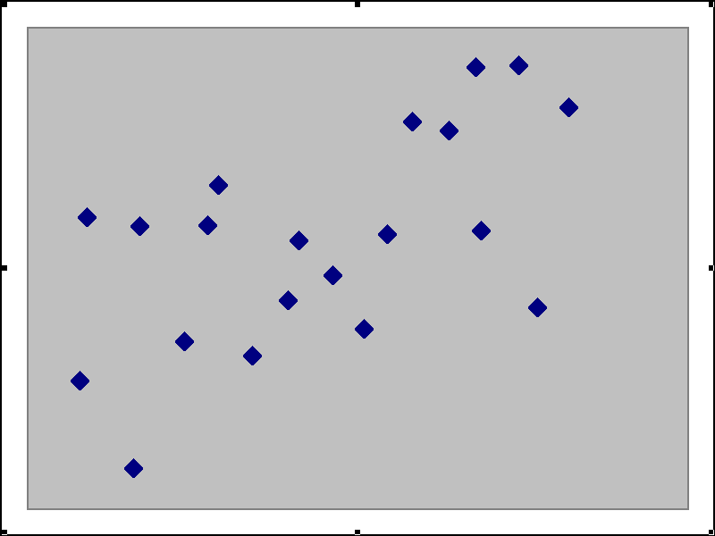
  - Moderate positive linear relationship
  - Weak negative linear relationship
  - Strong positive linear relationship
  - Strong nonlinear relationship

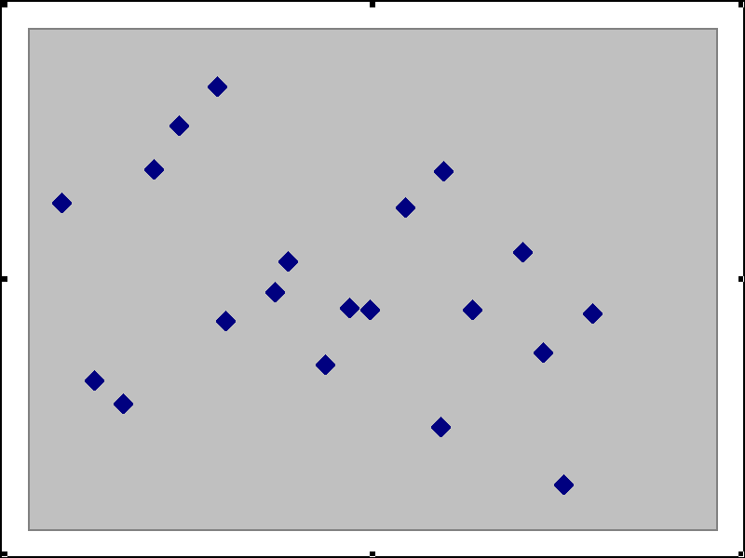

Problem 2: The scatter diagram to the left shows a
- Moderate positive linear relationship
- Weak negative linear relationship
- Strong positive linear relationship
- Strong nonlinear relationship

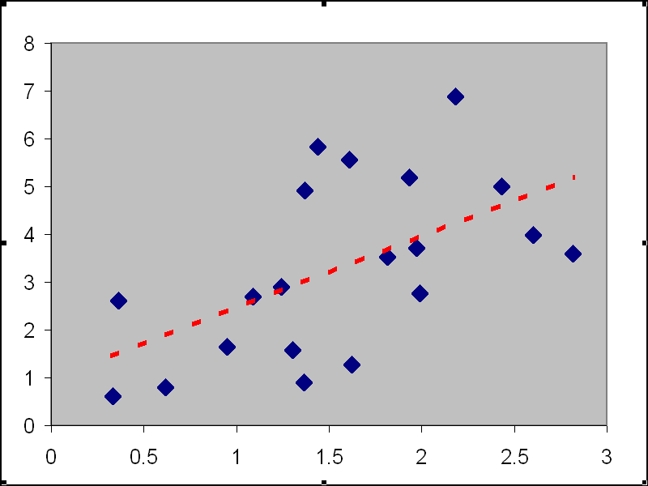
Problem 3: The least squares line to the right could be
  - Y = 1.5 X + 1
  - Y = – X – 2
  - Y = 0.5X – 3
  - Y = – 4X + 1

Problem 4: In a study of Y = weight in pounds versus X = age in months of certain dogs, the least squares regression line was found to be
Y = 2.7 X + 1.7
The slope has the interpretation
  - Newborn dogs, on the average, weigh 1.7 pounds
  - Dogs, on the average, weigh 17 pounds at one year
  - Newborn dogs, on the average, weight 2.7 pounds
  - Dogs, on the average, gain 2.7 pounds per month

Problem 5: A coefficient of determination R² measures
  - The slope of the least squares regression line
  - The percent of total variation explained by the least squares regression line
  - The relationship between the slope and the intercept of the least squares regression line
  - The size of the residuals of the least squares regression line
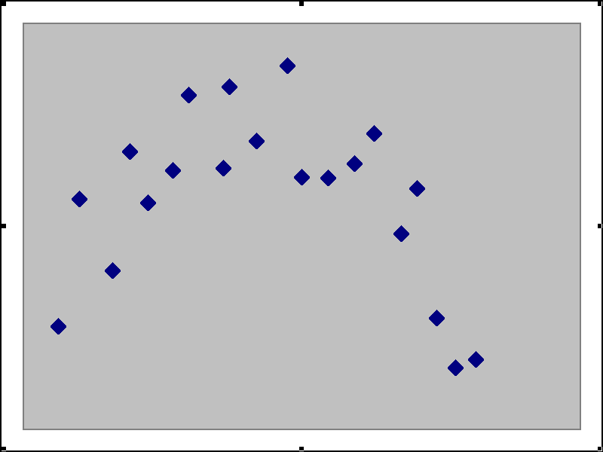
Problem 6: The residual plot to the right shows that
  - A linear model is inappropriate because of patterns
  - The correlation is positive
  - The intercept is negative
  - A linear model is inappropriate because of slopes

Problem 7: If a linear model is inappropriate because of a pattern in the residuals, one option to try to improve the model is to
  - Calculate the coefficient of determination
  - Switch the roles of X and Y
  - Transform the X or the Y variable
  - Ignore the residual plot

Problem 8: Using logarithmic transforms to Y and/or to X, we are able to fit which types of models?
  - Exponential and power
  - Interquartile range
  - Positive exponential but not negative exponential
  - Circular

Homework: pg 242 – 246; 1, 5, 11-14, 15, 22

